#####################Checkpoint 6.1##################

1. How entities are related to each other
2. Cardinality Ratio is how many entities can be related in the same way.
3. Participation constraints describe whether relationships are mandatory or optional.

####################Checkpoint 6.2###############

1b. 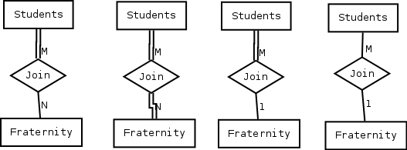

###################Checkpoint 6.3###################

1. 1(full):1 is a mandatory relationship. Each driver must have one and only one car.

3. M(full):N is a mandatory relationship. All cars must be driven by more than one driver.

#####################Checkpoint 6.4###################

1. Each passenger must be related to only one flight, and each flight must have more than one passenger. PK for passenger is “frequent flier_no” and PK for Flight is “flight_no” M(full):1

#####################Exercise 6.5###################

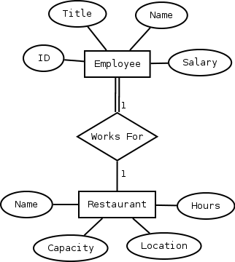

########################6.5a####################

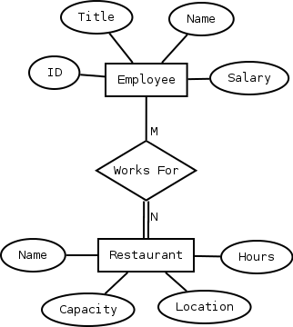

##########################6.5b#################

